Physics 20 Lesson 19 Uniform Circular Motion

Refer to Pearson pages 240 to 259 and 265 to 268 for a discussion about circular motion.

# Acceleration revisited

According to Newton’s second law, acceleration requires a net unbalanced force.



In Lesson 7 we learned that an acceleration results in a change in velocity. For example, consider an object moving at some initial velocity when it is acted on by a force which is in the same direction as the initial velocity. What is the result?

vi

The result is an increase in the speed without a change in the direction.

Vf

F

Now consider a slightly different situation – a force is applied at an angle to the initial velocity. What will be the result?

vi

The result is an increase in the speed and a change in direction.

Vf

F

It is apparent that acceleration can involve a change in speed and/or a change in direction, even though we often only think about the change in speed. Actually, this should not be surprising. Velocity is a vector that involves both speed and direction and, since acceleration is a change in velocity,



**a change in either speed and/or direction is an acceleration**.

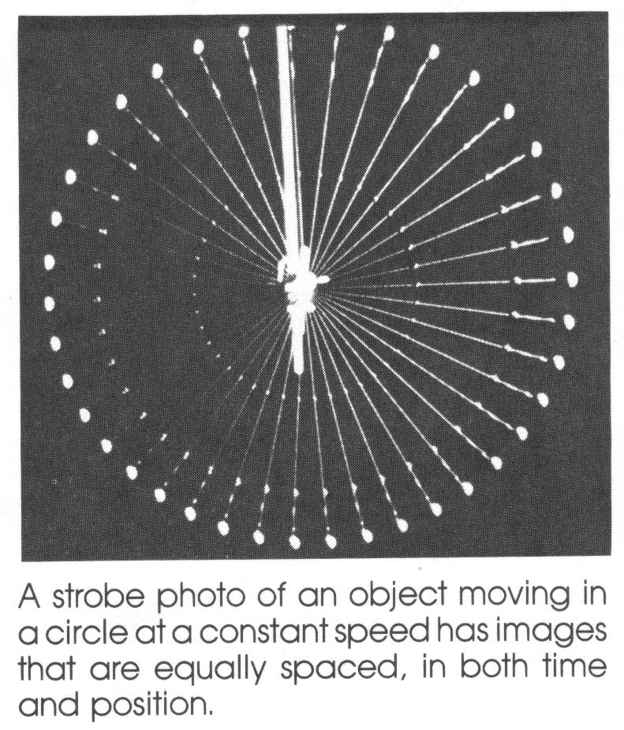

The figure to the right shows a strobe photo of a mass attached to a string moving at a constant speed. The mass moves at constant speed, but it is accelerating as evidenced by its constantly changing direction.

A net force that is perpendicular (90o) to the object’s motion does not effect the speed, it only effects the direction. Therefore, if a **perpendicular force** is constantly applied, the result is a constant speed with a continual change in direction. The result is **uniform circular motion**. Uniform circular motion involves an object moving in a circle at a *constant speed*. (Notice that the speed is constant and the velocity (i.e. direction) is constantly changing.) Uniform circular motion is accomplished by applying a force at 90o to the original motion of the object.

For example, when a ball is attached to a string the ball can be put into uniform circular motion by applying a constant tension force on the string.

v

The direction of the force is toward the centre of the circle.

**Centripetal force FC**

“centre - seeking” force

Fc

If the centripetal force is removed (i.e. the string is cut), the ball will continue to move at a constant velocity in a direction tangent to the point where the force was removed.

# Sources of centripetal force

Objects do not just decide to exhibit uniform circular motion on their own – there must be a force causing the circular motion. In other words:

*Circular motion is the effect of an unbalanced centripetal force acting at 90o to the velocity of an object. The unbalanced force is the cause of the circular motion.*

## 1. Tension force

When an object on a string or rope is put into circular motion, it is the tension in the string which provides the centripetal force.

FT = Fc

If the string or rope breaks, the object will continue moving in a straight line.

## 2. Friction force

When a car turns a corner, the friction of the road on the tires and/or the banking of the road provides the centripetal force.

Ff = Fc

If the frictional force is zero (i.e. – very icy conditions), the car will continue moving in a straight line and will not go around the curve.

## 3. Gravitational force

When satellites orbit the Earth or planets orbit the Sun, the centripetal force is provided by the mutual attraction of gravitation (see lesson 23).

Fg = Fc

# The direction of centripetal acceleration

Students often have difficulty in understanding how an acceleration can result in a change in direction without a change in speed. Consider the diagram to the right. An object is seen at point A with velocity  and then a very short time later it has velocity .  and  are equal in magnitude and differ in direction only.





r

A

The change in velocity may be determined graphically using vector addition.



–





or



In other words, we add a negative  (i.e. opposite direction) to . Note that  is pointing down which is toward the center of the circle. This means that the acceleration will also be directed toward the centre of the circle because it is in the direction of . This is why we refer to it as **centripetal** (centre-seeking) **acceleration** (ac).

# Uniform circular motion and speed

When we are working with the speed of an object, the basic equation for uniform circular motion is given by:

 (This equation is on your formula sheet.)

where: Fc - centripetal force (N)

m - mass (kg)

v - speed (m/s)

r - radius of circle (m)

(To see how this equation is derived, refer to Pearson pages 252 to 254.)

Calculate the centripetal force acting on a 2.5 kg object whirling at a speed of 3.5 m/s in a horizontal circle of radius 0.80 m.

Fc = m v2 = 2.5 kg (3.5 m/s)2 = **38.3 N**

r 0.80 m

If we use Newton’s second law (F = m a) we can write.



where: ac - centripetal acceleration (m/s2)

Combining  with 

we get: 

Noting that the mass cancels out, we get:

 (This equation is on your formula sheet.)

A car travelling at 20 m/s goes around an un-banked curve in the road which has a radius of 122 m. What is the acceleration experienced by the car? What provided the centripetal acceleration?

 = **3.27 m/s2**

The force that created the centripetal acceleration was the friction force between the tires and the road. If the friction force is not sufficient, the car will not be able to turn.)

# Period and frequency

Quite often we are given the *period* or *frequency* of rotation rather than the speed.

**Period** (symbol is T) is the time required for one circular rotation. The unit for period is seconds.

**Frequency** (symbol is f) is the number of rotations or cycles in a particular unit of time. The unit for frequency is rotations/second or cycles/second or Hertz (Hz). In other words, 1 Hz = 1 cycle/second.

Based on these definitions, we can see that period (time per rotation) and frequency (rotations per time) have an inverse relationship.

 (This equation is on your formula sheet.)

If the frequency of rotation for an object is 4.0 Hz, what is its period of rotation?

 = **0.25 s**

The relationship between *speed*, *period* and *frequency* can readily be understood by recognising that the distance that an object travels in one rotation is equal to the circumference (2 r) of the circle.

Recall that:



Since d = 2 r and t = T

 (This equation is on your formula sheet.)

If an object travelling in a circle with a radius of 5.0 m has a frequency of 6.0 Hz, what is the speed of the object?

First calculate T

 = 0.167 s

 = **188.5 m/s**

A very useful version of the centripetal force equation can be formed by substituting  into 





 (This equation is on your formula sheet.)

If the centripetal acceleration on a stone being whirled in a circle at the end of a 1.75 m string is 350 m/s2, what is the frequency of rotation?

Since we are given a centripetal acceleration rather than centripetal force we change  by recognising that Fc = m ac





A 1000 kg car enters an unbanked curve of 80 m radius. If the coefficient of friction between the pavement and the car tires is 0.51, what is the maximum speed which the car can go around the curve?

Begin with a free body diagram of the car.

FN = Fg = mg = 1000 kg (9.81 m/s2) = 9810 N

Ff =  FN = 0.51 (9810 N) = 5003 N

The frictional force provides the centripetal force:

Fc = Ff = 5003 N

•

FN

Fg

Ff



# Practice problems

1. A 5.00 kg object is attached to a rope. What is the tension in the rope if the object is travelling at 6.0 m/s in a circle with a radius of 4.50 m? (40 N)

2. If a centripetal force of 80.0 N causes a 6.00 kg object to travel in a circle once every 0.75 s, what is the radius of the circle? What is the speed of the object? (0.19 m, 1.6 m/s)

3. A force of 45.0 N causes an object to travel in a circle with a diameter of 7.50 m with a frequency of 0.60 Hz. What is the mass of the object? (0.84 kg)

4. An object rotates around a circle of radius 4.75 m. If the object completes 15 cycles in 35 s, what is the centripetal acceleration? (34.4 m/s2)

# Hand-in assignment

1. What is the centripetal acceleration of a small girl sitting on the outer edge of a merry-go-round which has a radius of 5.0 m an completes one revolution every 5.0 seconds? (7.9 m/s2)

2. An airplane flies in a horizontal circle of radius 1000 m. If its centripetal acceleration is 25 m/s2, how long does it take to complete one circuit? (40 s)

3. If a 7.95 kg object requires 5.00 minutes to complete 25 revolutions around a circle with radius 19.5 m, what is the centripetal force required? (42.5 N)

4. A string can exert a 4.0 N force without breaking. The string is used to whirl a 0.75 kg mass in a horizontal circle with a radius of 0.85 m. What is the minimum time to complete one revolution without breaking the string? (2.5 s)

5. The moon orbits the earth at a distance of 3.9 x 108 m. The moon requires 27.3 days to complete its orbit. What is the centripetal acceleration experienced by the moon? (2.77 x 10-3 m/s2)

6. Europa is a moon of the planet Jupiter. Europa requires 3.551 days to orbit Jupiter at a distance of 6.71 x 108 m. If the mass of Europa is 4.88 x 1022 kg, what is the centripetal force exerted on Europa by Jupiter? What kind of force is supplying the centripetal force? (1.37 x 1022 N)

7. A 1500 kg car enters a curve with a radius of 120 m. If the frictional force between the tires and the road is 4500 N, with what maximum speed could the car enter the curve without slipping off the road? (19.0 m/s)

8. An electron (m = 9.11 x 10-31 kg) moves in a circle whose radius is 2.00 x 10-2 m. If the force acting on the electron is 4.60 x 10-14 N, what is the speed of the electron? (3.18 x 107 m/s)

9. An athlete whirls a 3.7 kg shot-put in a horizontal circle with a radius of 0.90 m. If the period of rotation is 0.30 s,

A. What is the speed of the shot-put when released? (18.85 m/s)

B. What is the centripetal force acting on the shot-put? (1461 N)

C. How far would the shot-put travel horizontally if it is released 1.2 m above the level ground? (9.3 m)

10. A 932 kg car is travelling around an unbanked curve that has a radius of 82 m. What is the maximum speed that this car can round this curve if:

A. the coefficient of friction is 0.95? (27.6 m/s)

B. the coefficient of friction is 0.40? (17.9 m/s)

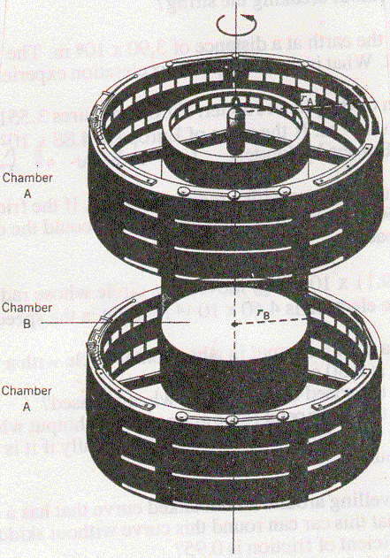11. A boy is riding a merry-go-round at a distance of 7.00 m from its center. The boy experiences a centripetal acceleration of 7.50 m/s2. What centripetal acceleration is experienced by another person who is riding at a distance of 3.00 m from the center? (HINT: The speed of the boys is NOT the same. What is the same for both boys?) (3.21 m/s2)

12. A space station is rotating to create artificial gravity, as the drawing indicates. The rate of rotation is chosen so the outer ring (rA = 2150 m) simulates the acceleration due to gravity on the surface of Venus (8.62 m/s2).

A. How long does it take the space station to turn around once on its axis; in other words, what is its period of rotation? (99.2 s)

B. What should be the radius rB, so the inner ring simulates the acceleration of gravity on the surface of Mercury (3.63 m/s2)? (905.4 m)

C. If you were on the space station, where would your feet be?